SQL CLASS - 9

TOPICS – Pseudo Columns

Pseudo Column –

- A pseudo-column behaves like a column but is not actually stored in the table.
- It is like a function in that it returns a value when selected.
- A pseudo-column is also similar to a function without arguments.
- You can select from pseudo-columns, but you cannot insert, update, or delete their values.
- This section describes these pseudo-columns:
- CURRVAL and NEXTVAL
- LEVEL
- ROWID
- ROWNUM
- SYSDATE
- USER

For Example –

CREATE TABLE student (std_id NUMBER,std_name VARCHAR2(30),marks NUMBER(6));
INSERT INTO student VALUES (seq_student.NEXTVAL, 'bishal','16-05-2020');
INSERT INTO student VALUES (seq_student.NEXTVAL, 'vidya','1-08-2019');
INSERT INTO student VALUES (seq_student.NEXTVAL, 'ajay','11-04-2018');

1. CURRVAL and NEXTVAL –

- A sequence is a schema object that can generate unique sequential values.
- These values are often used for primary and unique keys.
- You can refer to sequence values in SQL statements with these pseudo columns:
- CURRVAL: Returns the current value of a sequence.
- NEXTVAL: Increments the sequence and returns the next value.

Syntax –

CREATE SEQUENCE sequence_name;
CREATE TABLE table_name (id number);
INSERT INTO table_name VALUES (sequence_name.nextval, other_column_values);
SELECT sequence_name.currval FROM dual;
Examples –

CREATE SEQUENCE seq_student;
SELECT seq_student.CURRVAL FROM dual;
SELECT seq_student.NEXTVAL FROM dual;

2. LEVEL -

- LEVEL is a pseudo column which has a special function in hierarchical queries – it returns the position of any row in the hierarchy.
- For each row returned by a hierarchical query, the LEVEL pseudo column returns 1 for a root node, 2 for a child of a root, and so on.
- Consider the below hierarchy of employees in EMP table
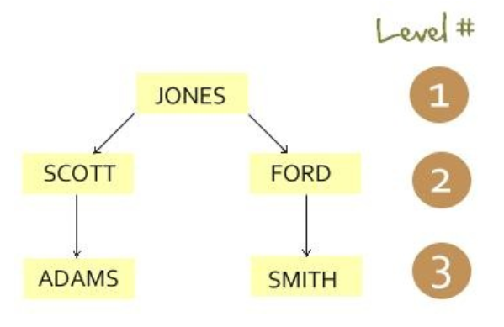
Syntax –

SELECT column_name, level
FROM table_name
START WITH condition
CONNECT BY PRIOR condition;

Example –

SELECT * FROM emp;

SELECT empno, ename, level
FROM emp
START WITH ename = 'JONES'
CONNECT BY PRIOR empno = mgr;

SYS_CONNECT_BY_PATH is valid only in hierarchical queries. It returns the path of a column value from root to node, with column values separated by char for each row returned by CONNECT BY condition.

SELECT empno, ename, level, sys_connect_by_path(ename, ' -> ') path
FROM emp
START WITH ename = 'JONES'
CONNECT BY PRIOR empno = mgr
ORDER BY level;

SELECT Level as Sequence
FROM dual
CONNECT BY Level <= 5;

SELECT Level+ (6-1) as Sequence
FROM dual
CONNECT BY Level <= 10;

3. ROWNUM –

- Oracle engine maintains the number of each record inserted by users in table.
- By the help of ROWNUM clause we can access the data according to the record inserted.

Syntax –

SELECT * FROM table_name WHERE conditions;

Example –

SELECT * FROM student WHERE rownum <= 3;
SELECT * FROM student WHERE rownum >= 3;
SELECT * FROM student WHERE rownum = 2;
SELECT * FROM student WHERE rownum <= 2;
SELECT rownum, st.* FROM student st order by STD_NAME;

4. ROWID –

- For each row in the database, the ROWID pseudo column returns a row’s address.
- The ROWID contains 3 information about row address:
- FileNo- means Table Number.
- DataBlockNo- means the space assigned by the oracle sql engine to save the record.
- RecordNo- Oracle engine maintains the record number for each record.
Syntax -

SELECT rowid, column_names FROM table_name;

Example –

SELECT rowid, std_name, marks FROM student;
SELECT rowid, std_name, marks FROM student WHERE std_name = 'ajay';

5. SYSDATE –

- It returns the current date and time of the OS where the Oracle Database resides whose type is DATE.
- The format of the returned date time value depends on the value of the NLS_DATE_FORMAT parameter.
- SYSDATE function cannot be used in the condition of a CHECK constraint.

Syntax -

SELECT rowed, column_names FROM table_name;

Example –

SELECT sysdate FROM dual;

SELECT
value
FROM
V$NLS_PARAMETERS
WHERE
parameter = 'NLS_DATE_FORMAT';

ALTER SESSION SET NLS_DATE_FORMAT = 'YYYY-MM-DD';

SELECT
sysdate
FROM
dual;

SELECT TO_CHAR(sysdate, 'MM-DD-YYYY HH24:MI:SS') FROM dual;
INSERT INTO student VALUES (seq_student.NEXTVAL,'ram', sysdate);
SELECT * FROM student WHERE joining_date > sysdate;

6. USER –

- This function returns the user name of the user who has logged in.

Syntax -

SELECT user FROM table_name;
SHOW USER;

Example –

SHOW USER;
SELECT user FROM dual;
INSERT INTO student VALUES (seq_student.NEXTVAL,user, sysdate);

__________________________THANK YOU____________________________

